Expt.-1: Small Angle Light Scattering
Aim: To determine the particle size in a colloidal solution (polystyrene beads) using scattering of light.
Apparatus: Diode Laser, Laser Power Supply, Optical Bench, Optical rail, aperture, goniometer, photodiode and detector, cuvette, colloidal solution of polystyrene beads.
Theory: The scattering of light may be thought of as the redirection of light that takes place when an electromagnetic (EM) wave encounters an obstacle or non-homogeneity. The non-homogeneity in our case is scattering particle. As EM wave interacts with particle, the electric orbits are perturbed with the same frequency as incident field. This oscillations in electron cloud results in induced dipole moment of molecule, which in turn emits electromagnetic radiation. Thus, scattering occurs when incident electromagnetic wave induces dipole moment in molecule, and this dipole moment emits radiation in different direction.
Types of Scattering:
- Elastic Scattering: Elastic scattering occurs when there is no difference in energy of incident and scattered electromagnetic wave. Hence, the incident and scattered wave will be of same frequency. The examples of elastic scattering are Rayleigh scattering and Mie scattering.
- Rayleigh Scattering: The Rayleigh scattering occurs when the particle size of the scatterer is much smaller than incident light wavelength (2πr/λ << 1). Rayleigh scattering happens in all direction uniformly. This type of scattering is strongly dependent on wavelength of incident light, but not on scatterer size. It is because of Rayleigh scattering; the sky looks blue.
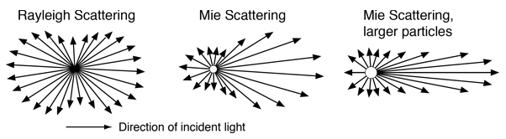
- Mie Scattering: The Mie scattering occurs when particle size is equivalent or greater than the wavelength of the incident light (2πr/λ ≥ 1). Unlike Rayleigh scattering, Mie scattering happens mostly in forward direction. Mie scattering is not too much dependent on the wavelength of incident light. Hence, it is the reason behind the white cloud. The intensity distribution of Mie scattering depends upon the size of the scatterer, so using Mie scattering, we can find particle size. The bigger particles do more forward scattering resulting in non-uniform distribution of scattered light.

- Inelastic Scattering: In inelastic scattering, the energy of scattered light is not same as incident light. So, the frequency of both the waves are not the same. The examples of inelastic scattering are Raman scattering and Compton scattering.
Working with nanoscale structures is difficult because we cannot see them with naked eyes. Or when we can, e.g. using electron microscopy, the observation conditions are very different from the sample’s natural conditions. Moreover, the amount of material characterized in any microscopy observation is so small that one can always doubt whether it is representative of the sample. In many situations, therefore, workers in the field of nanomaterials have to rely on indirect characterization methods, whereby a macroscopic amount of sample is analysed in its normal environment, but only incomplete structural information is obtained. Small Angle Scattering (SAS), which is the limiting case of Mie Scattering, is one such method by which, we can find size of the particles without going for much sophisticated and costly experimental setups like SEM, TEM and AFM. On top of that, Guinier’s approximation provides an easy way to determine particle size form SAS technique when particle size is comparable to the working wavelength, ie we are in Mie scattering region.
Mathematical treatment to find the particle size:
Figure below shows the schematic of the scattering.
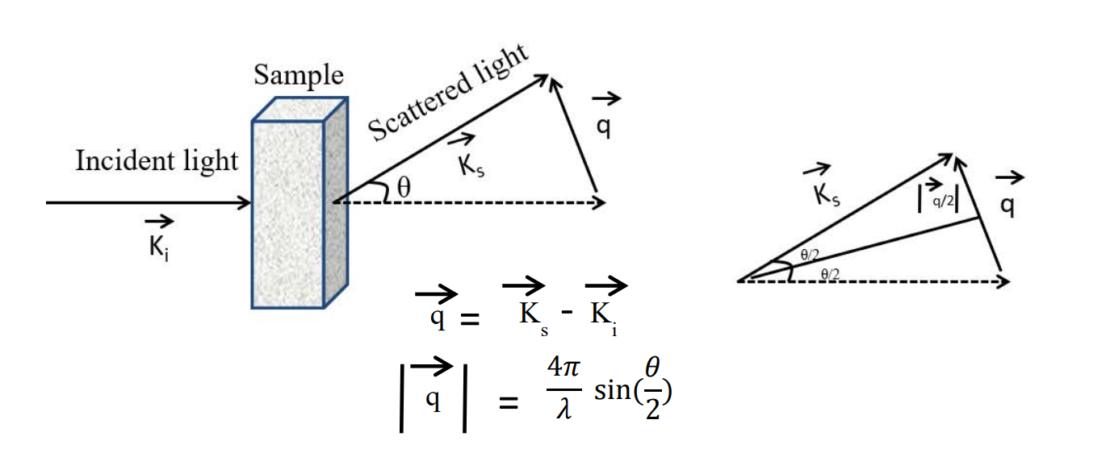Here, $\vec{K_{i}}$ and $\vec{K_{s}}$ are the wave vectors of incident and scattered light respectively, and $\vec{q}$ is the difference between them. The magnitude of $\vec{q}$ can be related to scattering angle θ as given in the equation. Guinier’s plot gives a tool to find the radius of gyration R_{g} of the molecule from the scattering profile.
Guinier’s approximation states that at low q the scattering profile can be approximated as follows:
$$I\left(q\right)=I\left(0\right)exp\left(-\frac{1}{3}q^{2}R_{g}^{2}\right)$$
Where, I(0) is the intensity at the zero scattering angle (q = 0), and I(q) is the intensity at some q (angle θ). Because of the exponential in the Guinier approximation, R_{g} and I(0) can be determined by performing a linear fit to a plot of ln(I) vs. q², called the Guinier plot. The region chosen for the linear fit is called the “Guinier region.”
The Guinier approximation only holds when the exponential is small. This means that to make a good Guinier fit, we need qR_{g} to be sufficiently small. The qR_{g} value at which the Guinier approximation starts to fail for a given scattering profile depends on the overall shape of the scatterer. For a spherical particle, qR_{g} should be less than 1. Validate it in the Guinier region.
By plotting ln(I) vs q², the slop of the graph gives $\frac{1}{3}R_{g}^{2}$.
Considering the particles as hard sphere, the true radius of particle is given by,
$$R= \sqrt{\frac{5}{3}}R_{g}$$
Precautions:
- While doing fine alignment, make sure that your hand does not touch LASER, otherwise it might change the orientation of LASER.
- In cuvette, there is one arrow on the top, that side (along with opposite side) will be used to incident the light. The other two sides will be rough. Handle the cuvette from the rough side, so that your fingerprint is not applied on the exposure side.
- While taking reading from the detector, make sure that no other light except scattered light falls on the detector.
Scattering Solution
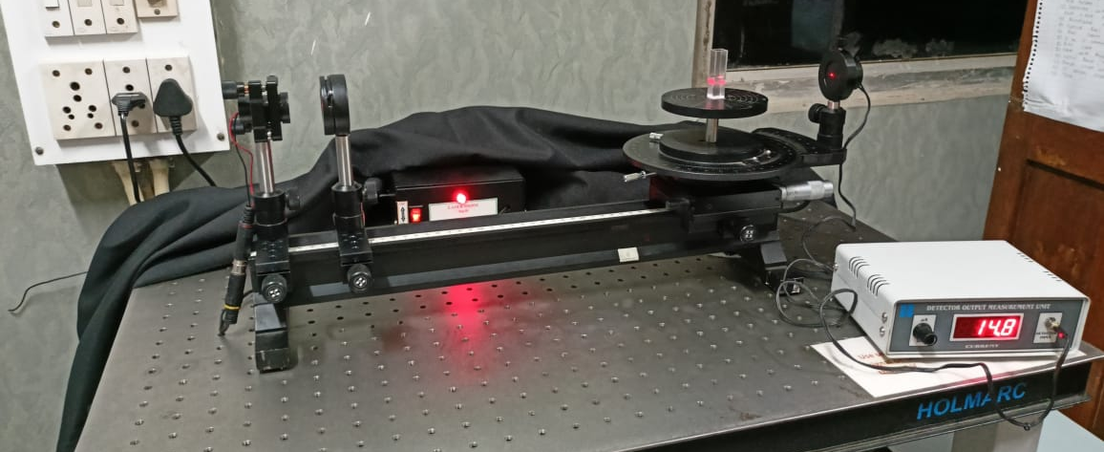
Photodiode
Goniometer
Aperture
LASER
Procedure:
Alignment:
- Turn on the LASER power supply and Photodiode.
- Use an aperture, move it back and forth to align the LASER on the optical rail.
- Confirm that the center of the LASER beam is passing through the aperture on entire railing. If due to mount, you cannot align the center of the beam, then align any one portion of the beam (say left or right portion), and make sure that the same portion is passing through the aperture for entire railing.
- Place the cuvette on the goniometer to confirm that beam is passing through the lower half of the cuvette.
- Align the photodiode in line with the LASER.
- Fill the cuvette with the colloidal solution of polystyrene beads and place it on the goniometer and align it perpendicular to the beam (If cuvette is not aligned, you will see 4 light spots on cuvette, when it is aligned, it will reduce to 2).
Data Measurement and Calculation:
- Place the aperture near to the LASER.
- Note the angle at which the direct beam is falling ie where current is maximum. This is your reference value.
- Measure the current values at reference angle, then move detector to 2° at either side and then start noting current values by increasing detector angle in steps of 0.5° interval. Take readings until you get same current value for 4 consecutive angles.
- Subtract the reference value from each angle to find θ consider only modulus of θ values if it comes negative.
- Find the different q values from θ.
- Plot the ln(I(q)) vs q² (Guinier’s plot).
- Fit this plot with linear regression in small region (4-5 points) of rapid fall in intensity (ln(I)) ie in the lower q region.
- Find out the slope and error in the slope.
- Using slop, find radius of gyration (R_{g}).
- Calculate q_{max}×R_{g} value and see if it is less than 1.3 or not (here q_{max} is the maximum value of q among the data points considered for linear regression).
- If is not less than 1.3, then take another set of data points to find the slope.
- From R_{g} calculate the R value considering particles are in spherical shape.
- Then find out the diameter of particle.
- Take care of error propagation in all the calculations.
Closing the Experiment:
- Turn off the LASER and photodiode.
- Cover the photodiode with plastic.
- Cover the setup with cloth.
Required Results:
- Scatter plot with linear fit
- Slope and error (m ± Δm)
- Radius of Gyration (R_{g} ± ΔR_{g})
- Value of q_{max}×R_{g}
- Radius of Particle (R ± ΔR)

References:
- http://plaza.ufl.edu/dwhahn/Rayleigh%20and%20Mie%20Light%20Scattering.pdf
- http://hyperphysics.phy-astr.gsu.edu/hbase/atmos/blusky.html#c2
- https://sites.google.com/a/umn.edu/mxp/student-projects/spring-2018/s18_mie-scattering
- https://bioxtas-raw.readthedocs.io/en/latest/saxs/saxs_guinier.html
- https://www.ncbi.nlm.nih.gov/pmc/articles/PMC8662971/pdf/j-54-01832.pdf
Additional Information:
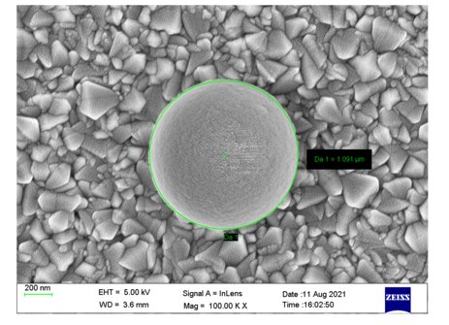
SEM image of Polystyrene Beads.

